Route 5 (NB) – Phase 2 Takhini Construction Detour
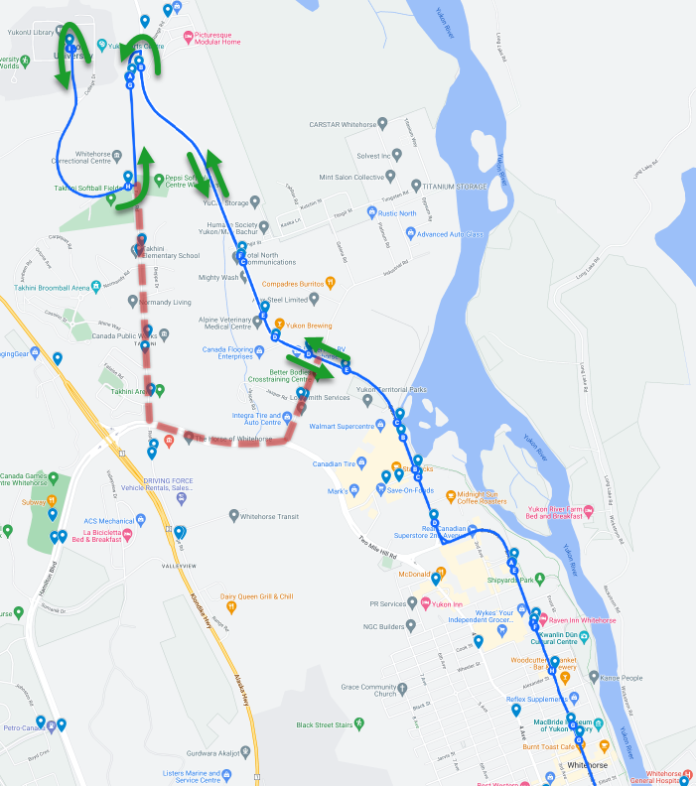

Schedule Changes
Order | Stop Name | S-00 | S-14
1 | City Hall | 6:40 AM | 8:40 PM
2 | 2nd Avenue & Front Street
3 | 2nd Avenue & Keish Street
4 | 2nd Avenue & Shipyards Park (NB)
5 | Quartz Road & Chilkoot Way (NB) | 6:43 AM | 8:43 PM
6 | Quartz Road & Chilkoot Centre (NB)
7 | Quartz Road & Industrial Road (NB)
8 | Copper Road (NB) | 6:47 AM | 8:47 PM
9 | Copper Road & Tlingit Street (NB)
10 | Range Road & Mountain View Drive (SB)
11 | University Drive & Range Road
12 | Yukon University | 6:52 AM | 8:52 PM
13 | Range Road & Mountain View Drive (NB)
14 | Mountain View Drive & Range Road (SB)
15 | Copper Road & Tlingit Street (SB)
16 | Quartz Road & Industrial Road (SB)
17 | Copper Road & Quartz Road
18 | Quartz Road & Chilkoot Centre (SB)
19 | Quartz Road & Chilkoot Way (SB) | 6:58 AM | 8:58 PM
20 | Quartz Road & 2nd Avenue
21 | 2nd Avenue & Shipyards Park (SB)
22 | 2nd Avenue & Ogilvie Street
23 | Yukon Courts Building | 7:03 AM | 9:03 PM

Services Changes

Transit Stops Added

Marwell
- Quartz Road & Industrial Road (NB)
- Copper Road (NB)
- Copper Road & Tlingit Street (NB)

Transit Stops Closed

Marwell
- Industrial Road & Jasper Road

Range Point
- Mountain View Drive & Range Road (SB)
- Range Road & Takhini Trailer Court
- Range Road & Crow Street (NB)
- Range Road & River Ridge Lane (SB)
- Range Road & Mountain View Place North (SB)
- Range Road & River Ridge Lane (NB)
- Range Road & Mountain View Place North (NB)
- Range Road & Crow Street (SB)

Takhini
- Range Road & Normandy Road (NB)
- Range Road & Rhine Way (NB)
- Range Road & Vimy Place
- Range Road & Normandy Road (SB)
- Range Road & Rhine Way (SB)

